Report IDM reference No. | 2MPZJ7 | Version: see IDM

Final Report
on Deliverable
MAT-1.3.2-T008-D001 Creep Fatigue Assessment Tool for year 2016

 |  | Deliverable-ID | MAT-1.3.2-T008-D001
Work Package | WPMAT | Date | 31 Oct. 2016
Project Leader | Michael Rieth
TS Title | Creep Fatigue Assessment Tool
TS Ref. No. | MAT-1.3.2-T008 | TS IDM-link | MAT-1.3.2-T008
Task Owner | Michael Mahler
RU(s) | KIT

Report Review & Approval
IDM role | Name(s)
Author | Michael Mahler
Co-author(s) | Jarir Aktaa
Reviewer(s) | Michael Gorley
PMU Reviewer | Eberhard Diegele, Matti Oron-Carl
Approver | Michael Rieth

 | Study / Assessment |  | Procurement / Commissioning of Hardware |  | Industry

 | Use of Facility | x | Other {please specify} – Interfacing and information exchange

Executive Summary
The Creep Fatigue Assessment (CFA) tool development has been continued in 2016 with focus on enhanced content and usability. The existing tool - developed in the past years - has been improved. In addition a tool usage workshop was delivered and support to new users was ongoing. For future tool extension an evaluation of available CuCrZr and W database have been done. Another point was the identification of requirements based on inelastic route. The tool itself got a new functionality based modified creep-fatigue assessment rule identified in the Creep-Fatigue task.

Comments (shortcomings, deviations, etc.)

Table of Contents
1 Introduction and tasks 3
2 Improve usability of CFA tool 4
2.1 Improve usability in ANSYS Workbench 4
2.1.1 Use of CFA package in ANSYS MAPDL 5
2.1.2 Use of CFA package in ANSYS Workbench 7
2.2 Run CFA tool on multiple cores 11
3 CuCrZr and W database for tool extension 12
3.1 Literature review on CuCrZr 12
3.2 Literature review on W 18
3.3 Summary 21
4 Requirements for inelastic route 22
5 Implementation of rule modifications 23
5.1 Implementation and use of rule modifications 24
5.2 Comparison of old and new rule 25
6 CFA tool usage workshop 25
7 Conclusions and Outlook 26
8 References 28

Abbreviations
BPVC | Boiler Pressure Vessel Code
CFA | Creep Fatigue Assessment
CF | Creep Fatigue
CPU | Central Processing Unit
CuCrZr | Copper Chrome Zirconia
dpa | displacement per atom
IDM | Internal Document Management
KIT | Karlsruhe Institute of Technology
MAPDL | Mechanical ANSYS Parametric Design Language
ROI | Region Of Interest
W | Tungsten
WB | Workbench

Symbols
Symbol | Description | Units
$$A$$ | Coefficient | [MPa^{-n}s^{-m-1}]
$$C_{1}$$ | Coefficient | n.a.
$$C_{2}$$ | Coefficient | n.a.
$$C_{3}$$ | Coefficient | n.a.
$$d_{c}$$ | Creep damage | [-]
$$d_{f}$$ | Fatigue damage | [-]
$$E$$ | Young’s modulus | [MPa]
$$m$$ | Time exponent | [-]
$$n$$ | Stress exponent | [-]
$$N_{d}$$ | Design allowable number of cycles | [-]
$$N_{f}$$ | Number of cycles to failure | [-]
$$Q$$ | Activation energy | [kJmol⁻¹]
$$R$$ | Universal gas constant | [Jmol⁻¹K⁻¹]
$$S_{y,avg}$$ | Average yield strength | [MPa]
$$S_{u,avg}$$ | Average ultimate strength | [MPa]
$$S_{y,min}$$ | Minimum yield strength | [MPa]
$$S_{u,min}$$ | Minimum ultimate strength | [MPa]
$$S_{i}$$ | Stress from monotonic stress vs. strain curve | [MPa]
$$S_{i,c}$$ | Stress from cyclic stress vs. strain curve | [MPa]
$$T$$ | Temperature | [°C], [K]
$$t$$ | Time | [s], [h]
$$T_{d}$$ | Time to rupture | [h]
$$∆ε$$ | Strain range | [-]
$${∆ε}_{eq}$$ | Equivalent strain range | [-]
$$∆ε_{t}$$ | Total strain range | [-]
$$ε$$ | Strain | [-]
$$ε_{c}$$ | Creep strain | [-]
$$\dot{ε}$$ | Strain rate | [s⁻¹]
$$θ$$ | Temperature | [°C]
$$σ$$ | Stress | [MPa]
$$σ_{1}$$ | Stress in x direction | [MPa]
$$σ_{2}$$ | Stress in y direction | [MPa]
$$σ_{3}$$ | Stress in z direction | [MPa]
$$σ_{iso}$$ | Isochronous stress | [MPa]
$$σ_{eq}$$ | Equivalent von Mises stress | [MPa]
$$σ_{r}$$ | Creep rupture stress | [MPa]
$$σ_{relax}$$ | Stress relaxation | [MPa]

Introduction and tasks
In-vessel components of fusion reactors are made out of structural materials and are subjected to high irradiation doses and temperatures. For this reason high irradiation resistance and creep strength is mandatory. The ferritic-martensitic steel EUROFER97 fulfils these requirements and is for these reasons a strong candidate for structural components of fusion reactors [1]. The high temperatures during operation of structural components lead to a combined damage mechanism including creep and fatigue damage.
For the design of these components with focus on creep-fatigue damage Özkan & Aktaa [1] developed in 2014 a Creep-Fatigue Assessment (CFA) tool which is able to evaluate the creep and fatigue damage as well as their interaction according to ASME Boiler Pressure Vessel Code (BPVC) Section III Division 1 Subsection NH [2]. This tool was developed for ANSYS MAPDL post-processor and uses the local stress, maximum elastic strain range and temperature from thermo-mechanical elastic analyses of a component performed with ANSYS to identify creep and fatigue damage by selecting of two nodes by hand.
In 2015 an extension of this tool was presented by Mahler & Aktaa [3] to be able to automatically identify the critical region of a component. For ANSYS MAPDL and Workbench the automated determination of the critical region was implemented by selecting a region of interest (ROI) where the creep-fatigue assessment runs and calculates the critical allowable number of cycles, the creep and the fatigue damage fraction [4] automatically.
The recent development of CFA tool in 2016 within the supporting task “WBS 1.3.2 – Enhancing Content and Usability” focuses in usability and extension of the tool. The continuation in 2016 includes the following tasks:
- Modify tool to improve the usability in Workbench (if possible) and add functionality to run tool on multiple cores
- Evaluate the availability of CuCrZr and W database for possible tool extension and identify gaps
- Identify requirements for future tool extension based on the inelastic route
- Introduce creep-fatigue assessment rule modifications identified in the Creep-Fatigue task
- Deliver tool usage workshop (preparation, execution, support)
- Provide support to new users
These tasks are worked in detail in the following chapters. The general idea and background of CFA tool is not included in this report. These details can be found in [1] and [3].

Improve usability of CFA tool
The CFA tool is still under development and for this reason improvement is ongoing. In 2016 the usability of CFA tool in combination with ANSYS Workbench has been improved (section 2.1). In addition the CFA FORTRAN code was re-written to be able to run CFA tool on multiple cores (see section 2.1.2).

Improve usability in ANSYS Workbench
The 2015 version of CFA tool and its use in ANSYS MAPDL and Workbench which is well described in [3] has been improved in 2016. The old version of CFA tool distinguished between CFA using ANSYS MAPDL and Workbench for post-processing. Two different script files packages were available depending on the use of ANSYS MAPDL or Workbench which were called
- CFA_MAPDL.zip Script files for ANSYS MAPDL
- CFA_WB.zip Script files for ANSYS Workbench
In addition to this disadvantage the use of CFA tool in combination with ANSYS Workbench was complicated and no result visualization was possible. Now the script file packages have been re-written and merged to one script file package independent of using ANSYS MAPDL or Workbench. The new script file package called
- CFA.zip
can be used for post-processing in ANSYS MAPDL or Workbench, respectively. This *.zip file contains three folders called:
- 00-Scripts
- 01-Temp
- 02-Results

The folder “00-Scripts” includes all *.mac script files for ANSYS MAPDL or Workbench post-processing and one file called “TOOLBAR”. This toolbar is the only file which the user has include in ANSYS by hand. During CFA results are temporary stored in the folder “01-Temp” where the CFA executable “CFA.exe” is located and after finishing the CFA the results are moved into the folder “02-Results”. In this folder all results are saved in subfolders. The names of these subfolders use the following convention:
- Hold-time-in-hours_irradiation-rate_model-type example: 1h_15dpa_model0
The use of new CFA script file package is explained in detail in section 2.1.1 for ANSYS MAPDL and in section 2.1.2 for ANSYS Workbench.

Use of CFA package in ANSYS MAPDL
The script file package “CFA.zip” must be extracted and copied to the current working directory of ANSYS MAPDL. In this working directory the result files of the thermal anaylsis for the temperature distribution, the primary and the primary + secondary stress analysis as well as the model file must be available with the following file names:
- Geometry data file: model.db
- Temperature result file for temperature distribution: thermal.rth
- Structural result file for primary loads: primary.rst
- Structural result file for primary + secondary load: primary+secondary.rst
Care has to be taken on the file names, because they are mandatory to be able to use the CFA tool.
The first step in ANSYS MAPDL is to add the toolbar for CFA. This can be done by clicking on “Parameters” and select “Restore Parameters”, see Figure 1. A new window opens and with the button “Browse” the file “!TOOLBAR” from the Subfolder “00-Scripts” in the folder “CFA” of the working directory can be selected.
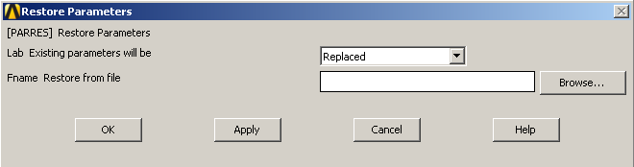
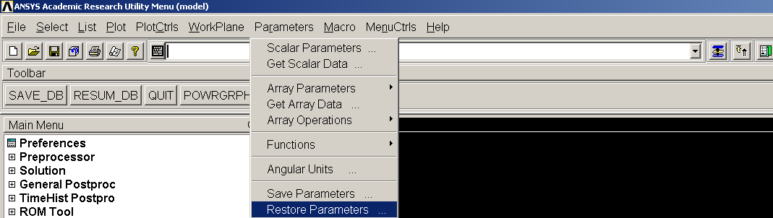
Figure 1 CFA tool add toolbar
After this step the toolbar is visible in ANSYS MAPDL as shown in Figure 2. Now two buttons are available which are called “CFA-FOR-ANSYS-WB” and “CFA-FOR-ANSYS-APDL”. Now it is important to press the correct button. In case of ANSYS MAPDL press on the button called “CFA-FOR-ANSYS-APDL”.
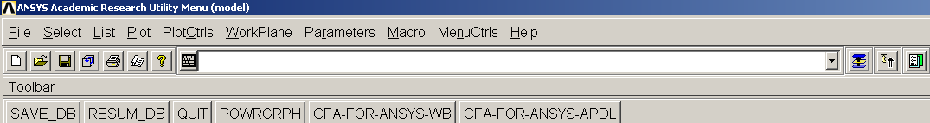
Figure 2 Toolbar for ANSYS WB and ANSYS MAPDL
In consequence a new window appears (see Figure 3) where the parameters for CFA can be defined like:
- Hold time in hours  - Irradiation rate in dpa  - Dimension  For 2D or 3D model use value 0  For axisymmetric model use value -1  - Selection  For selection of points use value 1  For lines use value 2  For areas use value 3  - Rule  For ASME C-F rule use value 0  For mod. C-F rule use value 1  (see section 5) | 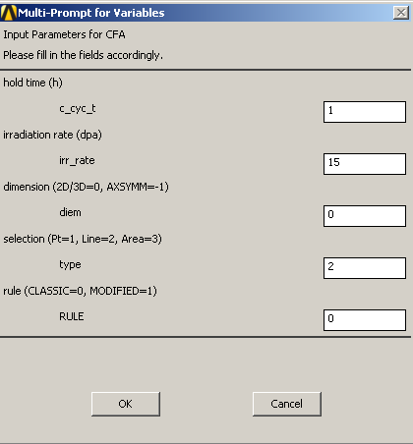  Figure 3 Parameters for CFA using ANSYS MAPDL

After definition of CFA parameters the toolbar in ANSYS MAPDL is changing to the one shown in Figure 4. The button “PARAMETER-FOR-CFA” is already processed by the popup window for CFA parameters before. The next steps are the boxes 2-5 where the inner and outer geometry have to be defined before the CFA can be started with button 6. This procedure is very well described in [3] and not explained in the recent report.
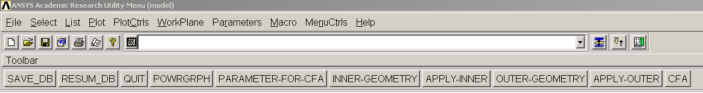
1
2
3
4
5
6
button:
Figure 4 CFA with post-processing in ANSYS MAPDL
Finally the CFA result is shown in ANSYS MAPDL and in addition it is stored in the subfolder “02-Results” of the folder “CFA” (working directory). As an example the result of an axisymmetric model with inner pressure and different temperatures on the inner and outer surface is shown in Figure 5 for hold time of one hour, irradiation rate of 15 dpa and the creep-fatigue rule as mentioned in ASME BPVC [2].
In general the use of the new CFA script file package for ANSYS MAPDL is comparable to the old version presented in 2015 [3]. Only the initial steps are different because of compatibility reasons with ANSYS Workbench.

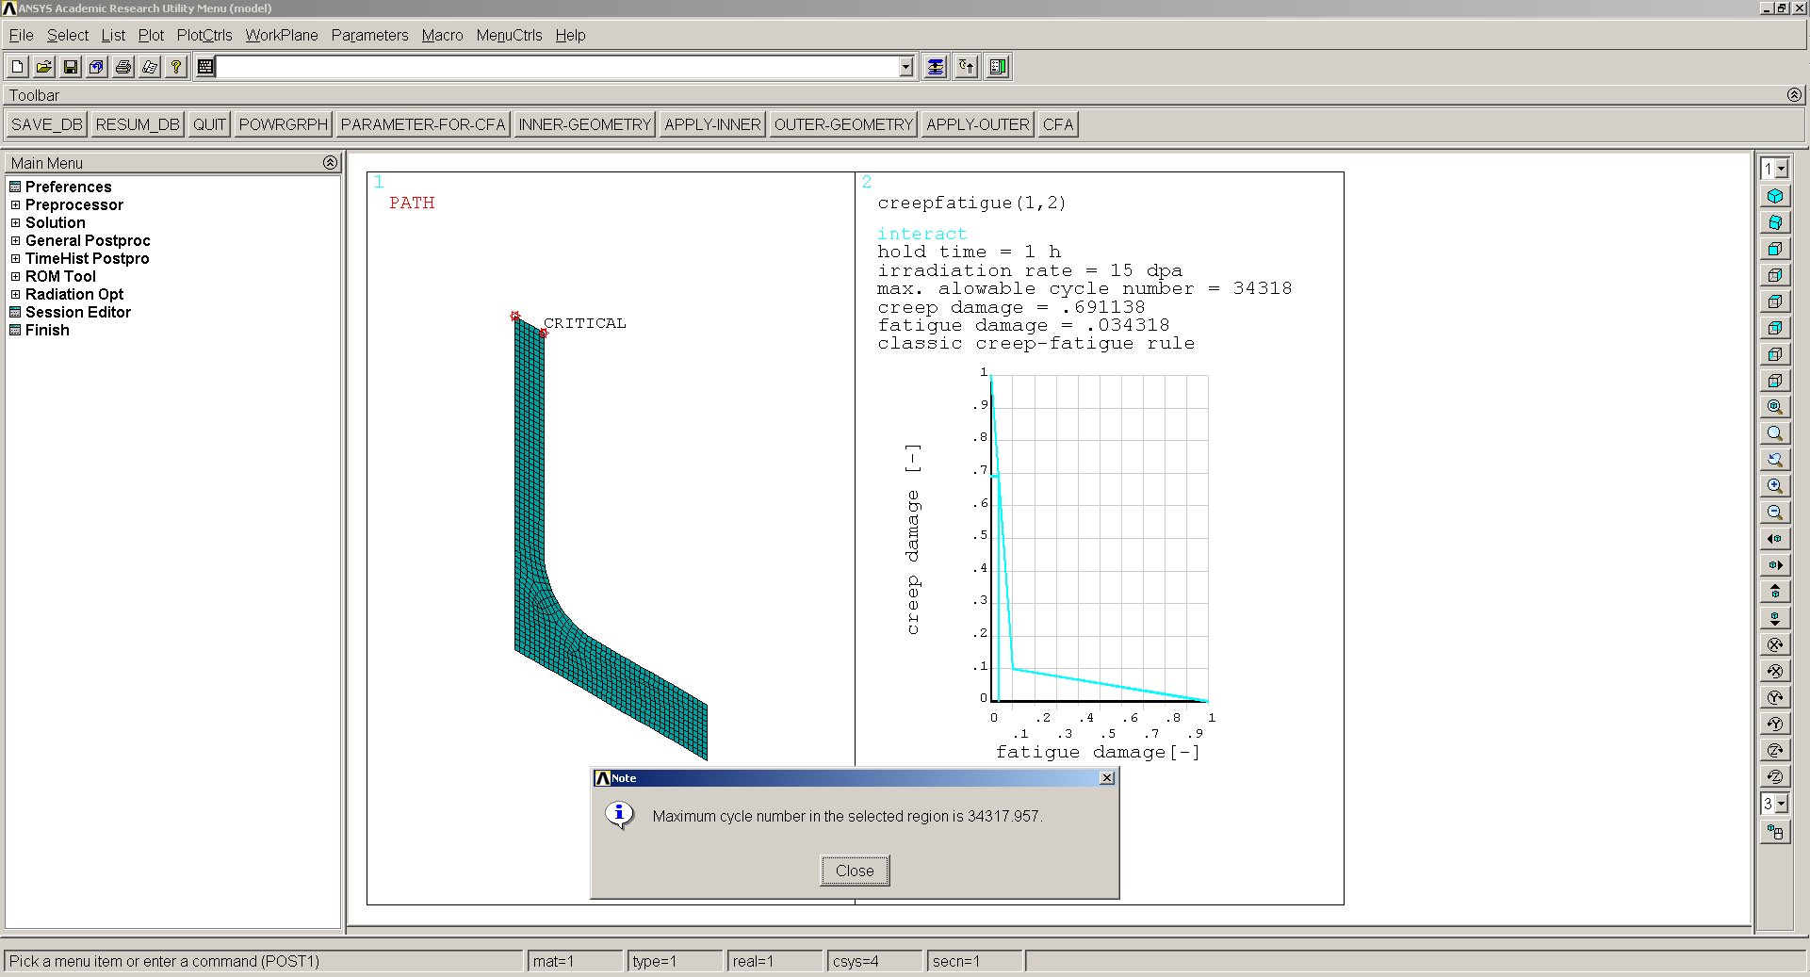
Figure 5 Example CFA post-processing result in ANSYS MAPDL

Use of CFA package in ANSYS Workbench
As before shown for ANSYS MAPDL now for ANSYS Workbench the script file package “CFA.zip” must be extracted and copied to the current working directory. The basis for CFA are the already solved analyses for the
- Temperature distribution,
- Primary loads and
- Primary + secondary loads
in ANSYS Workbench. An example how these three preliminary analyses could be performed in ANSYS Workbench is shown in Figure 6.
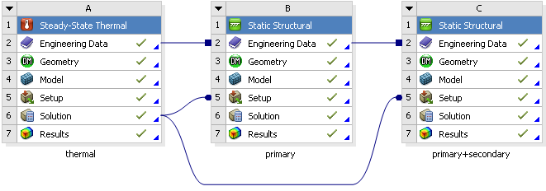
Figure 6 Required analysis for CFA
The left box shows the steady-state thermal analysis for the temperature distribution and the box in the middle and on the right show the static structural elastic analyses for primary and primary+secondary loads, respectively. The primary+secondary analysis includes the influence of thermal expansion compared to the primary one. Nevertheless both analyses are linked to the thermal analysis to receive temperature information.

For CFA the region of interest (ROI) must be defined. In detail the inner and outer region where the assessment will be performed. Therefore two components have to be created in the “Model” of the thermal analysis (right click on “Model” of thermal analysis and then click edit, see Figure 7 left). Two new components are required where one must be called “CFAINNER” and the other one “CFAOUTER”, see Figure 7 middle. Be careful to use the right names because exactly these names are required for future Creep Fatigue Assessment. An example of selected inner and outer regions is shown in Figure 7 right for 3D quarter symmetry model of a bellow. This bellow is under internal pressure and has different temperatures on the inner and on the outer surface resulting in a temperature gradient through wall thickness.
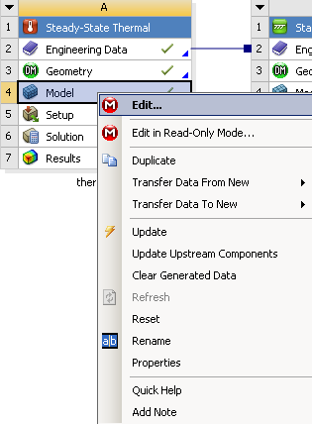 | 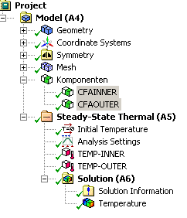 | 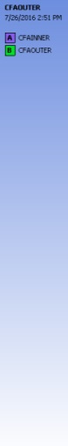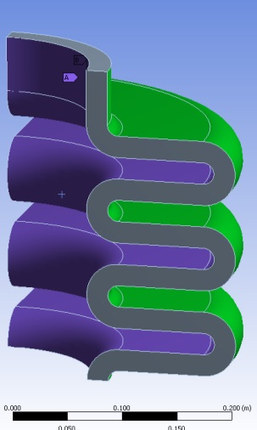
Figure 7 Definition of inner and outer surface for CFA

For the use of CFA tool in combination with ANSYS Workbench four “Mechanical APDL” modules are necessary. Three of them are used to transfer the result file from the native ANSYS Workbench simulation. For illustration they are named
- Thermal.rth
- Primary.rst
- Primary+secondary.rst
and highlighted in Figure 8 with a red box. Due to internal restrictions in workbench the “Jobname” associated within a “Mechanical APDL” module is called “file”. This initial name must be changed to “thermal”, “primary” and “primary+secondary” in the properties of each module (see as an example for thermal “Mechanical APDL” module the green boxes in Figure 8). In the following the result files of initial “thermal”, “primary” and “primary+secondary” simulation must be linked with the corresponding “Mechanical APDL” modules by creating connections (purple lines) as shown in Figure 8.
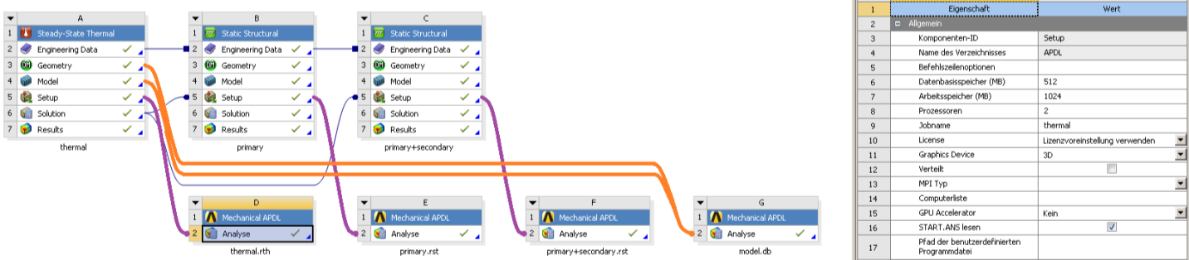
0
0
Figure 8 Mechanical APDL modules in ANSYS Workbench
The last “Mechanical APDL” module which was not highlighted yet needs in total 5 connections. Two of them must be connected to “Geometry” and to “Model” of the thermal simulation, respectively (orange lines in Figure 8). With these two links the ROI (“CFAINNER” and “CFAOUTER”) is connected to the “Mechanical APDL” module. In addition three more connections to the last “Mechanical APDL” module are required for combination of all result files. For this reason the previous “Mechanical APDL” modules are linked with the last one (red lines in Figure 9). As before, the “Jobname” of last module must be renamed from initial “file” to “model” (green box in Figure 9).
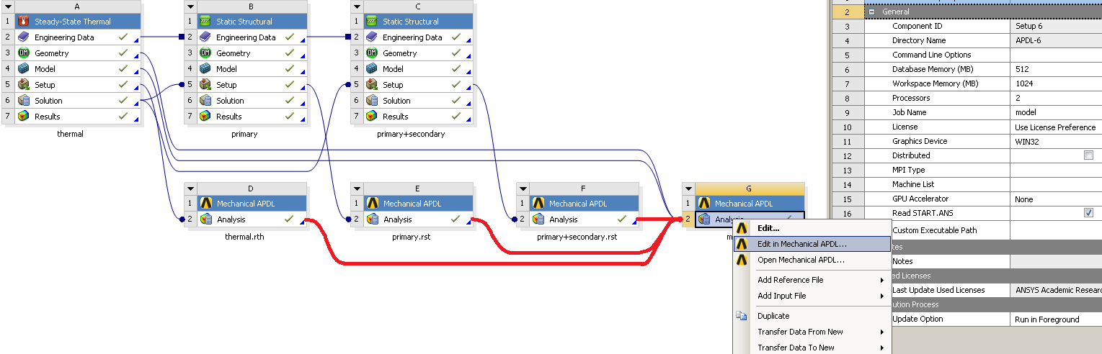
0
0
Figure 9 Last Mechanical APDL module in ANSYS Workbench
Finally all definitions in ANSYS Workbench are done and the CFA can be started by switching to ANSYS MAPDL by clicking on “Edit in Mechanical APDL” of the last “Mechanical APDL” module (blue box in Figure 9). ANSYS MAPDL will open automatically and the “TOOLBAR” have to be added in ANSYS MAPDL as shown before in Figure 1. For CFA based on ANSYS Workbench model the button “CFA-FOR-ANSYS-WB” must be pressed, see Figure 10.
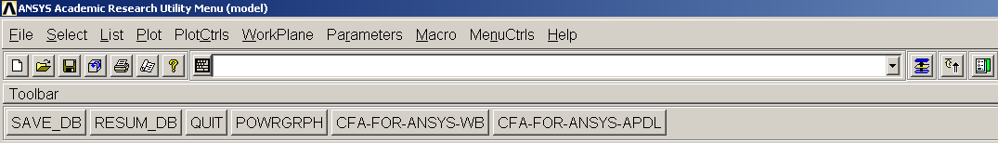
Figure 10 Toolbar for ANSYS WB and ANSYS MAPDL
A new window opens where the input parameters for CFA can be defined like:
- Hold time in hours
- Irradiation rate in dpa
- Dimension
- Rule
The definition of these parameters is the same as shown in section 2.1.1. After applying the parameters for CFA the window is changing and the selected nodes of the ROI from ANSYS Workbench can be shown by clicking on “SHOW-SELECTION” and finally the CFA starts by pressing the button “CFA”, see Figure 11.
The CFA result based on the ANSYS Workbench model is shown in ANSYS MAPDL and in addition stored in the subfolder “02-Results” of the folder “CFA” in the working directory. As an example the result of 3D quarter symmetry model with inner pressure and different temperatures on the inner and outer surface is shown in Figure 12 for hold time of 1 hour, irradiation rate of 15 dpa and the creep-fatigue rule as mentioned in ASME BPVC [2].
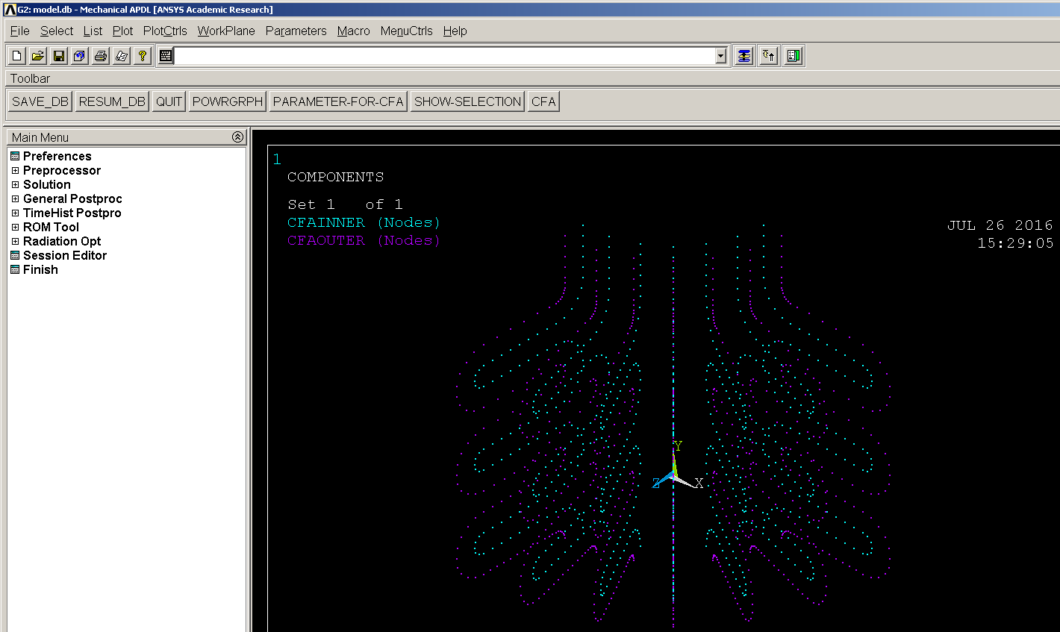
Figure 11 CFA with post-processing in ANSYS MAPDL based on ANSYS Workbench model
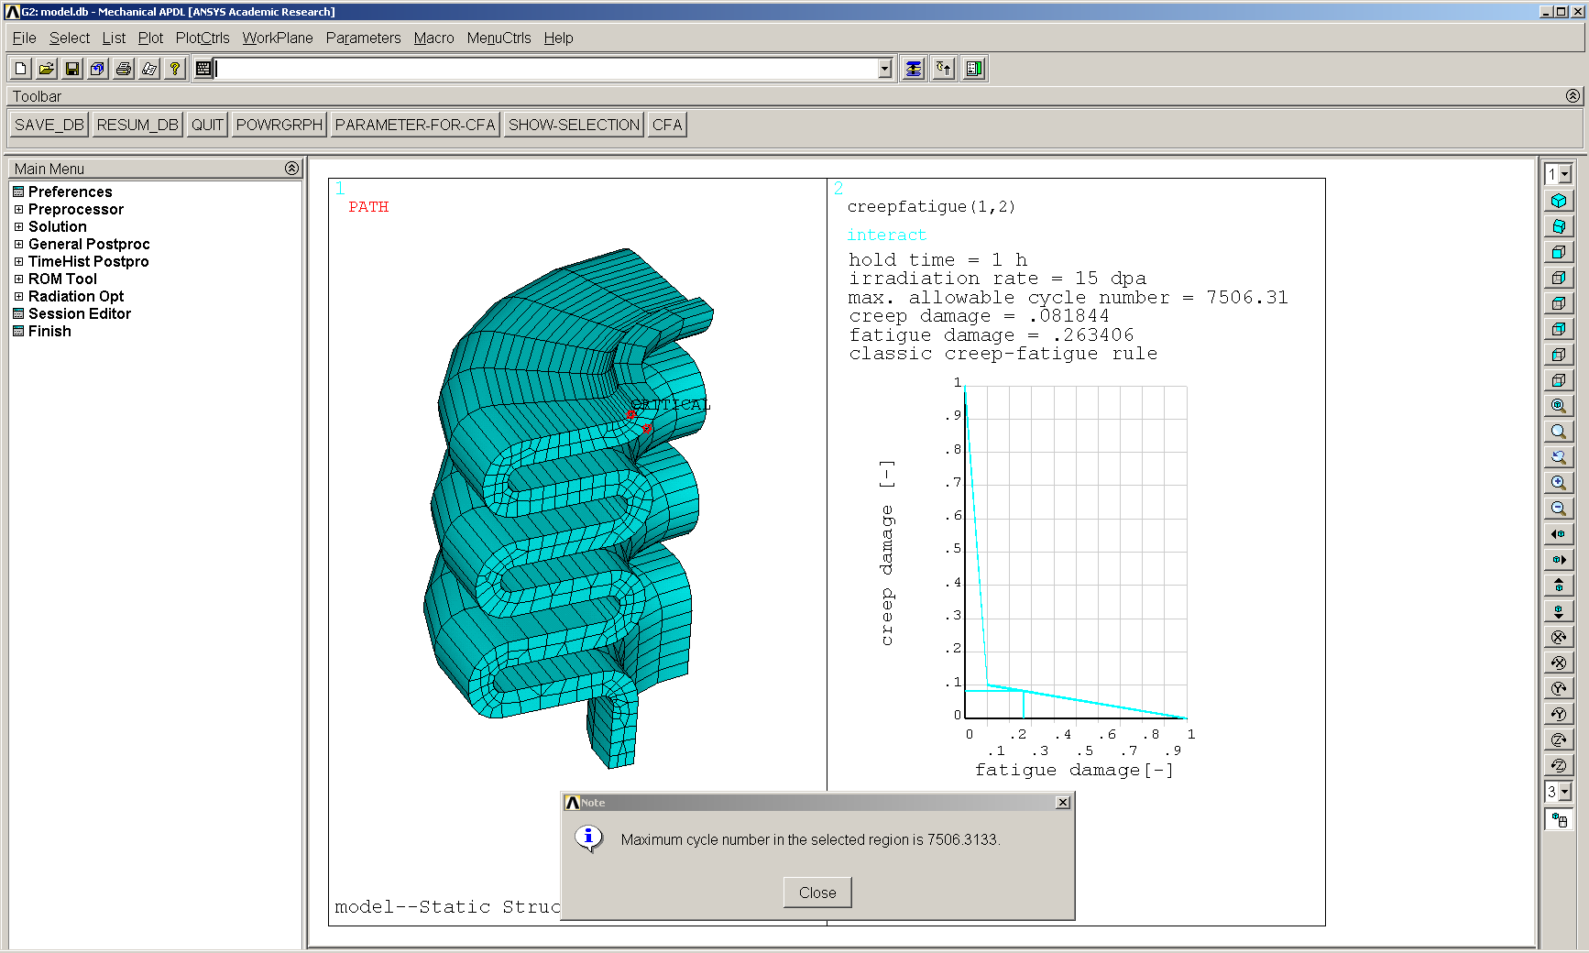
Figure 12 Example CFA post-processing result in ANSYS MAPDL based on ANSYS Workbench model
In the last year report [3] the following disadvantages were mentioned:
- Definition of CFA input parameters is not user-friendly.
- A visualization of the results like in ANSYS MAPDL is not possible.
- Use of ANSYS MAPDL is recommended instead of ANSYS Workbench
Within the recent report a big improvement of CFA tool usage in combination with ANSYS Workbench was presented. Now fewer steps are necessary to be done by the user itself compared to the old version of CFA tool for ANSYS Workbench. But the biggest advantage is that now the result visualization based on ANSYS Workbench models is available and the definition of input parameters is very easy. Now the author recommends using either ANSYS Workbench or ANSYS MAPDL, because the use of CFA is for both systems very easy.

Run CFA tool on multiple cores
In the past the CFA tool executable itself was only able to be run on single core. As a consequence the assessment takes quite a long time. With regard to the big number of paths, which are analysed to find the critical one within the region of interest, an improvement of simulation time was mandatory. After extensive rewriting local variables of CFA tool FORTRAN source code it is now possible to run the tool on multiple cores. As an example Figure 13 shows the CPU load during CFA executable run with single core on the left and with eight cores on the right.
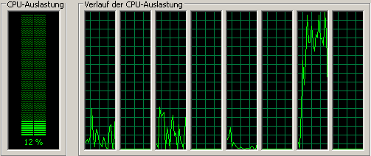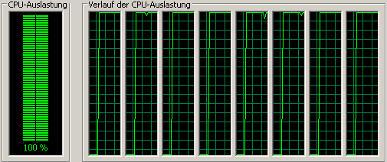
Figure 13 Single- and multi-core CFA
To show the efficiency of this improvement 3D benchmark geometry has been used processing about 3100 paths. Figure 14 shows on the left the FE mesh, in the middle the selected ROI with the inner and outer surface and on the right the comparison of computation time for single- and multi-core run. The blue bar shows the time for ANSYS post-processing which is equal for both assessments, because ANSYS post-processing do not allow using multiple cores. This problem can only be solved if not all paths are assessed. In this case specific criteria’s to pre-select some paths before ANSYS post-processing are mandatory. Possible criteria could be region with maximum temperature or stress. This exercise is proposed as a task for 2017. Nevertheless an improvement has been achieved for CFA executable itself where the simulation time is reduced by factor of 5.
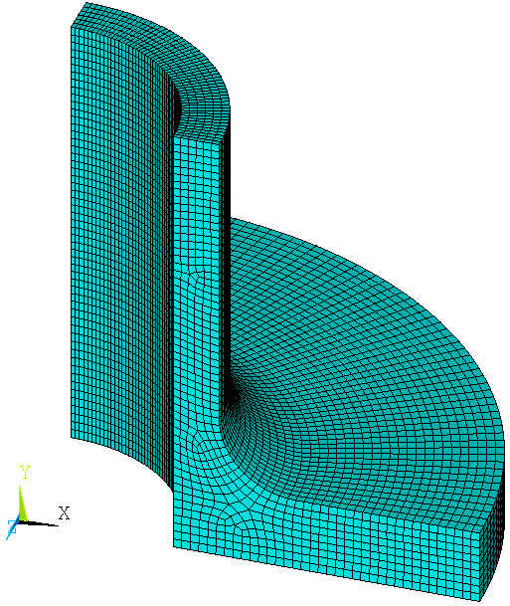 | 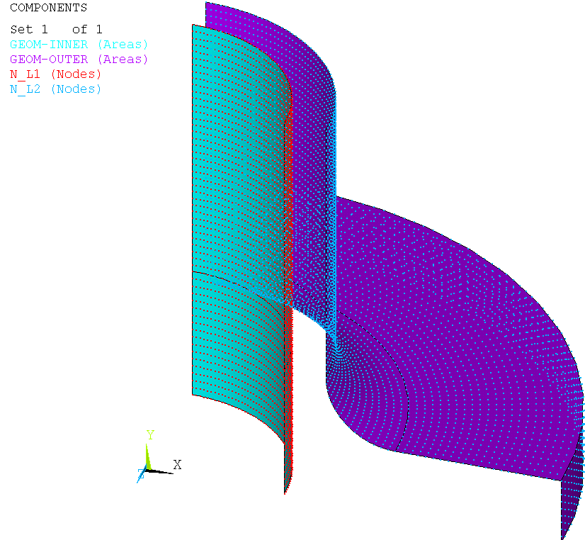
Figure 14 Efficiency of multi-core CFA

CuCrZr and W database for tool extension
In the current implementation of CFA tool components made of EUROFER97 in a temperature range between room temperature and 550°C can be assessed. In this implementation isochronous stress vs. strain curves are for example predicted using a constitutive model for EUROFER97 developed by Aktaa&Schmitt [5]. In cases where no constitutive model is available for the prediction of these curves they must be experimentally determined for the material of interest. Furthermore the CFA tool needs to be re-written to be able to directly use e.g. experimental isochronous stress vs. strain curves. This exercise should be added to 2017 tasks because in literature isochronous stress vs. strain curves for EUROFER97 have been found [6] newly.
For possible future tool extension the material database for CuCrZr and W was studied based on literature. In general the different material data listed below are mandatory for the temperature range of interest:
- Design fatigue curves ($∆ε_{t}-N_{d}$)

- Creep stress vs time to rupture curves ($σ_{r}-T_{d}$)

- Monotonic / isochronous stress vs. strain curves ($σ_{mono}/σ_{iso}-ε$)

- Creep-fatigue damage interaction diagram ($d_{c}-d_{f}$)

- Material properties like
Young’s modulus ($E$)
Minimum yield stress ($S_{y,min}$)
Minimum ultimate stress ($S_{u,min}$)

Literature review on CuCrZr
In general copper alloys are used as heat sink in high heat flux regions like in ITER because of their advantage having excellent thermal conductivity and acceptable strength [7]. Within the ITER SDC-IC code [7] a special ITER CuCrZr grade was proposed and called CuCrZr-IG with its chemical composition as shown in Table 1.
Table 1 Chemical composition of CuCrZr-IG [7]
Alloy | Alloying Elements, wt.%
 | Cu | Cr | Zr | Impurities
CuCrZr-IG | Balance | 0.6 - 0.9 | 0.07 - 0.15 | Total < 0.15, including:  Co < 0.05, Nb < 0.10, Ta < 0.01  O as low as possible

In general mechanical properties of CuCrZr-IG strongly depend on heat treatment and are distinguished in ITER SDC-IC as
- Treatment A: Solution annealed, cold worked, aged
- Treatment B: Solution annealed, aged
- Treatment C: Typical treatment for First Wall and Divertor
In ITER SDC-IC the most data is available for Treatment B. For the other two treatments the mechanical properties are more limited. Whenever other literature than ITER SDC-IC is used for material database the treatment is not clear, but ITER SDC-IC data used in a) – e) is based on Treatment B. The maximum operation temperature mentioned in ITER SDC-IC is 350 °C. For this reason only temperatures between room temperature and 350 °C are of major interest. In the following the different required available material data for possible CFA extension are listed in a) – e).
- Design fatigue curve ($∆ε_{t}-N_{d}$) reference: [7]
In ITER SDC-IC [7] design fatigue curve is available for CuCrZr (Figure 15) with different strength parameter and all data are treated as one set. So the curve is valid for all treatments and for temperatures between room temperature and 350 °C. Consequently this curve could be used for CFA tool extension.

Figure 15 CuCrZr: Design fatigue curve
- Creep stress vs time to rupture curves ($σ_{r}-T_{d}$) reference: [8]
The Larson-Miller approach can be used to identify creep stress vs. time to rupture if specific requirements (temperature independence) can be demonstrated [8]. Based on a lot of creep data between 100 °C and 300 °C the Larson-Miller equation for CuCrZr [8] can be formulated as:

$T(25+\log\left(T_{d}\right))=6.392∙{10}^{4}-1.991{∙10}^{4}\log{σ}$ ($T$ [K], $T_{d}$ [h], $σ$ [MPa])

With this equation the stress vs. time to rupture curves can be calculated as shown in Figure 16 and this data could be used for CFA tool extension.

Figure 16 CuCrZr: Creep stress vs. time to rupture curves
- Monotonic / isochronous stress vs. strain curves ($σ_{mono}/ σ_{iso}-ε$)
No isochronous stresses vs. strain curves were found in literature for CuCrZr. But the isochronous curves can be constructed by adding strain resulting from tension and creep [6]. The creep component is often calculated from extended fit to creep deformation results like [6]

$ε_{c}=C_{1}t^{C_{2}}σ^{C_{3}}$

Using now monotonic stress vs strain curves in combination with creep deformation curves yields finally the constructed isochronous stress vs. strain curves.

- Monotonic stress vs. strain curves reference: [7]
The monotonic stress vs. strain curves shown in Figure 17, which are tabular listed in [7], can be used as basis for calculation of isochronous stress vs. strain curves and as input for possible CFA tool extension.
Figure 17 CuCrZr: Monotonic stress vs. strain curves
- Creep deformation curve reference: [9], [10]
Based on creep strain rate

$\dot{ε}=Ae^{\left(-\frac{Q}{RT}\right)}σ^{n}t^{m}$

and an integration with respect to time the creep strain can be described as:

$ε=\frac{1}{m+1}A∙e^{-\frac{Q}{RT}}σ^{n}t^{m+1}$ (ε [-], t [s], T [K])

When using the appropriate parameters shown in Table 2 [10] the creep deformation curve in Figure 18 can be calculated e.g. for test temperature of 216 °C of different stress levels [9].
Table 2 Parameters for creep strain rate on CuCrZr [10]
Material | Temp. | Applied  stress | Coefficent  A | Activation Energy | Stress  exp. n | Time  exp. m
Material | [°C] | [MPa] | [MPa^{-n}s^{-m-1}] | [kJmol⁻¹] | [-] | [-]
Cu-0.65Cr-0.1Zr | 216 | 183 … 282 | 7.56·10¹¹ | 197 | 3 | -0.92
NOTE: A threshold stress of 159 MPa must be subtracted from $σ$ before using the equation!

Figure 18 CuCrZr: Creep deformation curves
- Constructed isochronous stress vs. strain curve
Based on monotonic stress vs. strain [7] and creep deformation curves [9], [10] the isochronous stress vs. strain curves are calculated by adding tension and creep strain as described in [6] for 100, 200, and 300 °C, see Figure 19 - Figure 21. As it can be seen the influence of creep up to 100 °C can be ignored and at 200 °C the influence of creep is small. In case of 300 °C the effect of hold time is visible, but due to rare data it is not recommended to use this data for possible CFA tool extension. For example the influence of short and long hold times seems to be the same. Better isochronous curves are mandatory because the shown here are based on extended fit to creep deformation results obtained at 216 °C only.
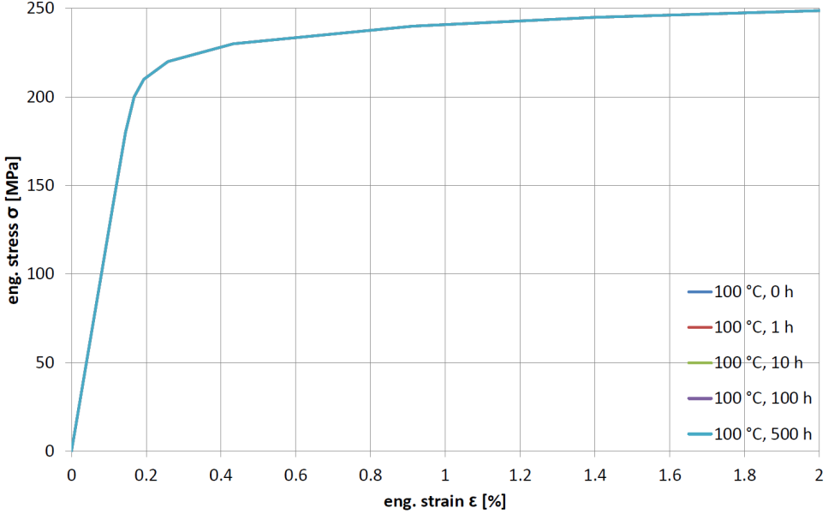
Figure 19 CuCrZr: Isochronous stress vs. strain curve 100 °C
Figure 20 CuCrZr: Isochronous stress vs. strain curve 200 °C
data not recommended
Figure 21 CuCrZr: Isochronous stress vs. strain curve 300 °C
- Creep-fatigue damage interaction diagram ($d_{c}-d_{f}$) reference: [11]
For the calculation of creep and fatigue damage the creep-fatigue damage interaction is very important. Based on experimental results at 300 °C and dwell times of 30 and 300 seconds creep-fatigue damage was studied in [11]. Figure 22 shows creep-fatigue interaction diagram and proposed allowable region in grey with its tip point (0.1, 2·10⁻⁴). The effect of longer hold times (more than 300 seconds) is not clear and the proposed creep-fatigue damage interaction should be used with care. The data shown here is not recommended for use in possible CFA tool extension.

data not recommended
Figure 22 CuCrZr: Creep-fatiegue interaction diagram
- Material properties like:
Young’s modulus ($E$), min. yield stress ($S_{y,min}$), min. ultimate stress ($S_{u,min}$) reference: [7]

In addition to fatigue and creep material data the basic mechanical properties like youngs modulus, yield and ultimate stress are necessary. The dependency of these values on temperature is shown in Figure 23 and can be used for possible CFA tool extension

Figure 23 CuCrZr: Additional mechanical properties
In summary based on the available literature data with its rough data based on few results CFA tool extension for CuCrZr is in general not recommended now, because of limited material data especially in case of isochronous stress vs. strain curves and creep-fatigue damage interaction diagram.

Literature review on W
Tungsten with its high temperature capability and low erosion rate makes it a candidate armour material for different regions in ITER DIVERTOR [7]. In case of ITER pure powder metallurgical sintered tungsten is considered for application. The typical chemical composition of pure tungsten mentioned in ITER SDC-IC with its maximum impurities is listed in Table 3.
Table 3 Chemical composition and allowable impurities of tungsten [7]
Element | Max. composition | Permissible variation  in check analysis
Element | [wt.%] | [wt.%]
C | 0.01 | ± 0.002
O | 0.01 | + 10% relative
N | 0.01 | + 0.0005
Fe | 0.01 | + 0.001
Ni | 0.01 | + 0.001
Si | 0.01 | + 0.001

For tungsten there is no maximum operation temperature mentioned in ITER SDC-IC. Nevertheless most data are listed between room temperature and 1200 °C. At higher temperatures recrystallization effects occur. For this reason this temperature range seems to be of major interest and will be assumed to be the operation temperature window. In the following different required available material data for possible CFA tool extension are listed in Figure 24 - Figure 28.
- Design fatigue curves ($∆ε_{t}-N_{d}$) reference: [12], [13]
Design fatigue curve for tungsten is not available in literature. Only experimental fatigue lifetime (number of cycles to rupture) data for 25 °C, 815 °C and 1232 °C could be found [12], [13]. Nevertheless based on these data design fatigue curves can be calculated according to ASME (Section III, Div. 1, Appendix III). All experimental data are curved fitted by one equation

$∆ε_{t}=a_{1}+a_{2}{N_{f}}^{a_{3}}$

using the method of least squares with error equation for total strain like

${∆ε}_{t,err}={\left|1-\frac{{∆ε}_{t,fitting}}{{∆ε}_{t,exp.}}\right|}^{2}.$

Finally the design fatigue curves are obtained by multiplying with a factor of 0.5 on strain range or a factor of 20 on cycles dependent on which value is smaller:

$∆ε_{t}=MIN\left\{{0.5∙(a}_{1}+a_{2}{N_{d}}^{a_{3}}),a_{1}+a_{2}{{(20∙N}_{d})}^{a_{3}}\right\}$

This design fatigue curve can be used for possible CFA tool extension.
Figure 24 W: Design fatigue curve
- Creep stress vs time to rupture curves ($σ_{r}-T_{d}$) reference: [14], [15], [16]
In reference [16] a Larson-Miller plot for tungsten is available and corresponding stress vs. time to rupture curves are shown in [15] and [14] but the Larson-Miller equation is missing. The author of the present report tried to determine this equation based on the available diagram shown in [16] which yields the following equation for selected data in temperature range between 870 °C and 1650 °C:

$T\left(15+\log\left(T_{d}\right)\right)=-60.4668σ+32326.762$ ($T$ [°C], $T_{d}$ [h], $σ$ [MPa])

With this Larson-Miller equation the creep stress vs. time to rupture curve can be calculated as shown in Figure 25 and can be used for possible CFA tool extension.

Figure 25 W: Creep stress vs. time to rupture curves

- Monotonic / isochronous stress vs. strain curves ($σ_{mono} / σ_{iso}-ε$) reference: missing data
No isochronous stresses vs. strain curves are available in literature. In addition neither monotonic stress vs. strain nor creep deformation curves have been found in literature. Here is a lack of data for W.

missing data
Figure 26 W: Monotonic and isochronous stress vs. strain curves
- Creep-fatigue damage interaction diagram ($d_{c}-d_{f}$) reference: missing data
The interaction of creep and fatigue according to its damage behaviour is also missing in literature. No creep-fatigue interaction diagram has been found in literature. Here is lack of data for W.

missing data
Figure 27 W: Creep-fatigue damage interaction diagram

- Material properties like
Young’s modulus ($E$), avg. yield stress ($S_{y,avg}$), avg. ultimate stress ($S_{u,avg}$) reference: [7]
In ITER SDC-IC [7] young’s modulus as well as yield and ultimate stress can be found, see Figure 28. But for yield and ultimate stress only average values and no minimum values are listed. The ASME BPVC uses normally the minimum values. Nevertheless the temperature dependence of these mechanical properties is shown in Figure 28.

Figure 28 W: Additional mechanical properties
In case of W the available material data in literature is very limited. No monotonic and isochronous stress vs. strain curves and no creep-fatigue damage interaction diagram have been found. Due to this lack of material data it is not possible to add W database to CFA tool at the moment.

Summary
In chapter 3 the available literature material data for future CFA tool extension have been reviewed. In general a lot of different temperature dependent material data for tension, creep, fatigue and creep-fatigue are necessary for the material of interest.
In case of CuCrZr for each required material property data have been found in literature. But in some cases only few data are available and the reliability on these data is limited. For this reason it is not recommended to use presented CuCrZr database to expand CFA tool.
For material W the literature review yields less data compared to CuCrZr and for example monotonic and isochronous stress vs. strain curves are not available as well as creep-fatigue damage interaction diagram. For this reason possible CFA tool extension is for W also not possible at the current stage.
As one of the 2017 tasks the author suggests first to change the complete structure of CFA tool to be able to use experimental data instead of predicted curves based on a constitutive model. Until now for EUROFER97 curves like monotonic and isochronous stress vs. strain curves are predicted because of missing experimental data. Instead of predicted curves now the existing EUROFER97 experimental literature data (like isochronous stress vs. strain curves [6]) can be used for CFA tool. With this extension other materials like CuCrZr can be added in the future without the need of constitutive models.

Requirements for inelastic route
Until now the CFA tool uses preliminary elastic FE analysis to calculate fatigue damage, creep damage and allowable number of cycles based on specific assumptions mentioned in ASME BPVC Section III Subsection NH in T-1430 [2]. The structure of CFA tool which follows the steps mentioned in T-1430 (elastic route) is shown in Figure 29. As it can be seen the required steps are complicated and a lot of equations are checked and used to finally calculate the creep and fatigue damage. The procedure how T-1430 is implemented in CFA tool is explained in [1], [3] in more detail.

Figure 29 CFA tool program structure based on elastic analysis FE analysis
In case of inelastic analysis ASME BPVC Section III Subsection NH T-1420 can be used for calculation of fatigue damage, creep damage and allowable number of cycles. Using inelastic analysis makes it easier to calculate the fatigue and creep damage, because no estimation of the inelastic part on total strain range is required. It is available directly from previous FE analysis. The possible principle structure of CFA tool in case of inelastic analysis is shown in Figure 30. In comparison it is obvious that the use of data from inelastic FE analysis makes it easier to do creep-fatigue assessment. Due to the fact that stress linearization is not necessary the CFA tool could be run very fast. The green box shows the input from preliminary FE analysis which is required for CFA, namely:
- Stress components$σ_{1}$,$σ_{2}$,$σ_{3}$
- Temperature $θ$
- Equivalent von Mises Stress $σ_{eq}$
- Equivalent total strain range ${∆ε}_{eq}$
The implementation of this inelastic route can be added to 2017 task specification.

Figure 30 CFA tool progam structure based on inelastic analysis FE analysis

Implementation of rule modifications
Based on an assessment for the applicability of creep-fatigue accumulation rules of ASME BPVC and RCC-MR rules to 9Cr-steels in 2014 [17] modification of these rules have been proposed by Aktaa as follows:

- Calculation of creep damage portion in the creep fatigue accumulation rule in
- first 10% of the lifetime using S_{i} from monotonic stress strain curves and design creep curves of as received material assuming no effect of cyclic softening on stress-to-rupture curves
- remaining 90% of the lifetime using S_{i,c} from cyclic stress strain curves and design creep curves of cyclic softened material
- Using allowable total creep fatigue damage values of RCC-MR for SS 316 and Grade 91 - envelope with (0.3,0.3) tip point.

This modification requires in general material data not yet available for 9-Cr steels like Eurofer. Namely creep lifetime data for cyclic softened material. For this reason a test matrix [18] has been proposed in 2015. Nowadays the proposed modifications have been simplified by Aktaa [19] by introducing a so called cyclic softening stress factor ($K_{Ψ}$) for easier implementation in existing design codes. The mentioned simplified modifications have now been implemented into the CFA tool and can be used in addition to the “classical” rule mentioned in ASME BPVC.

Implementation and use of rule modifications
The creep-fatigue rule modifications proposed by Aktaa [19] and mentioned briefly in chapter 5 have been implemented into CFA tool FORTRAN source code in addition to the already available creep-fatigue rule used by ASME BPVC.
This implementation is based on the assumption that for the remaining 90% of lifetime the cyclic stress vs. strain curves of Eurofer97 [6] will be used for temperature range between 20 and 550 °C to calculate $S_{i,c}$ based on the cyclic curves instead of $S_{i}$ from monotonic curves. The ratio
$ψ=\frac{S_{i,c}}{S_{i}}$
allows now to include the effect of cyclic softening in combination with the so called $K_{Ψ}$ approach. More details about the way of implementation can be found in [19]. Due to the fact that $K_{Ψ}$ is a function of the softening level $ψ$, which is not fully determined yet, the current implementation uses $K_{Ψ}$ defined as
$K_{Ψ}=\frac{1}{ψ}$
This assumption is required because the tests for identification of $K_{Ψ}$ are currently in progress [19] and not finished yet.
The end-users of CFA tool can now decide during definition of the parameters in the so called “Multi-Prompt for Variables” which rule they would like to use for CFA, see Figure 31. In Figure 31 the parameter definition for creep-fatigue rules when using ANSYS MAPDL and ANSYS Workbench is shown on the left and right. The value “0” is for the rule as mentioned in ASME BPVC and value “1” uses modified rule by Aktaa.

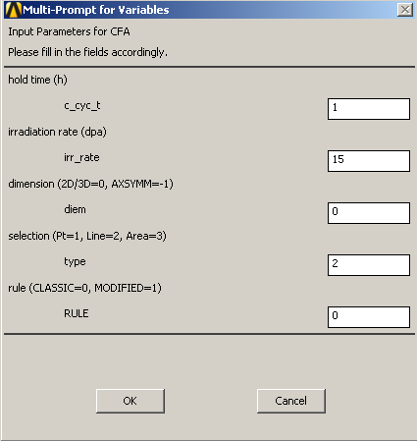 | 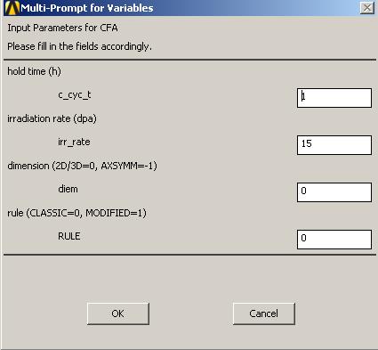
Figure 31 Definition of classic or modified creep fatigue rule, left: based on ANSYS MAPDL, right: based on ANSYS Workbench

Comparison of old and new rule
In this section the influence of using classical rule of ASME BPVC or modified rule by Aktaa [19] is figured out. To show the effect an axisymmetric FE model of a muff with inner pressure and different temperatures on the inner and outer surface has been used for elastic thermal, primary and primary+secondary simulations. For CFA the inner and outer model geometry is used as region of interest (ROI). The assessment is based on CFA parameters of 1 hour hold time and an irradiation rate of 15 dpa. The result for classical and modified rule is shown in Figure 32 on the left and right, respectively.
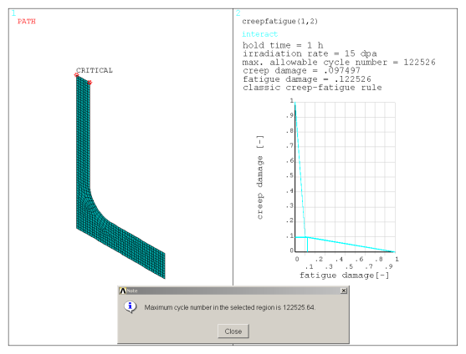 | 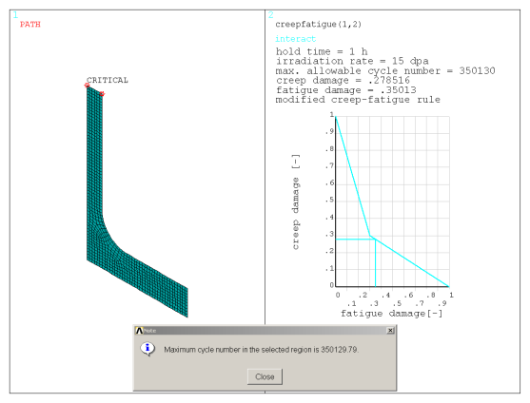
Figure 32 Comparison of classic (left) and modified creep-fatigue rule (right)
Due to the different rules the allowable number of cycles, creep and fatigue damage is changing. The application of creep-fatigue accumulation rule like in ASME BPVC [17] has shown in the past that creep damage is underestimated [17]. When using the modified rule this conservatism is now improved. In this example the classic rule yields maximum number of allowable cycles of 122525 and the modified rule of 350129. With this new rule this conservatism can be reduced.

CFA tool usage workshop
One major point of 2016 task specification for CFA tool was to provide a workshop for possible users (designers) where the tool is presented. The content of this workshop for CFA tool includes a general overview of CFA tool and basics about the theoretical background. The corresponding presentation can be found on IDM (link). The second part of the workshop was focused on practical use of CFA tool where the participants had the opportunity to use CFA tool by their own on worked 2D and 3D examples in ANSYS MAPDL and ANSYS Workbench, respectively. The presentation and also the worked examples are available on IDM (link).
Another important point of the CFA tool workshop was the release of CFA tool itself. The participants had the opportunity to receive CFA tool after signing a “Licence Agreement for use of CFA tool” where the users have:

- Non-exclusive and non-transferable right to use the software within EUROfusion
- No right to use it for other activities
- No distribution to any third party without prior written consent to KIT
Finally 13 users signed this agreement and got the 2015 version of CFA tool. These users have now the possibility to be supported by the developer of CFA tool as specified in the task specification. For new users beyond the workshop there is a short description of CFA tool available on IDM (link) including the contact data for requesting CFA tool.

Conclusions and Outlook
The usability of CFA tool has been improved in 2016. Especially the use of ANSYS Workbench is now much more comfortable compared to the old version. In addition there is result visualization available when using ANSYS Workbench in the same way as for ANSYS MAPDL. For easier use of CFA tool the script files packages have been combined and only one package is available for ANSYS MAPDL and Workbench.
The availability of CuCrZr and W database has been review based on data available in literature. Due to the identified gaps a tool extension for CuCrZr or W is not recommended. The biggest problems are due to missing isochronous stress vs. strain curves and missing creep-fatigue interaction diagrams. Table 4 summarizes the required minimum data and its availability for tool extension in case of CuCrZr and W.
Table 4 Required minimum data and its availability for tool extension
Material data |  | CuCrZr | W
Design fatigue curves | $$∆ε_{t}-N_{d}$$
Creep stress vs. time to rupture curves | $$σ_{r}-T_{d}$$
Monotonic stress vs. strain curves | $$σ_{mono}-ε$$
Isochronous stress vs. strain curves | $$σ_{iso}-ε$$
Creep-fatigue damage interaction diagram | $$d_{c}-d_{f}$$
Young’s modulus | $$E$$
Minimum yield stress | $$S_{y,min}$$ |  | ()
Minimum ultimate stress | $$S_{u,min}$$ |  | ()

To include the inelastic creep-fatigue rule of ASME BPVC the requirements have been figured and there are less steps required compared to the available rule based on elastic analysis. The implementation of inelastic creep-fatigue rule into CFA tool is proposed as task for 2017.
Another improvement of CFA tool which has been made is that the rule modification proposed by Aktaa [18] is now available in current version of CFA tool. The users have the possibility to use creep-fatigue rule of ASME BPVC as well as the modified one [18].
The 2015 version of CFA tool, which is well described in [3], was released during EDDI workshop in March 2016 and designers within EUROfusion are now able to use CFA tool.
For the future there are further CFA tool developments proposed as task specifications for 2017:
- Change CFA tool structure to be able to use experimental data and add existing EUROFER97 experimental literature data instead of prediction with constitutive model

- Provide support to existing and new users

- CFA tool extension to add inelastic route of ASME BPVC

- Improve general usability of CFA tool (e.g. critical path)

- Identify requirements for future tool extension based on RCCMR code and review rules of SDC-IC and R5 procedure.

References

[1] | F. Özkan und J. Aktaa, „Final Report Initial Creep-Fatigue Assessment tool development Deliverable EDDI-1.3.2 D2 Task No. EDDI-1.3.2-02,“ 2014.
[2] | ASME, Boiler Presssure & Vesselt Code, Section III, Division 1, Subsection NH, Appendix T, 2004.
[3] | M. Mahler und J. Aktaa, „Status Report on the Development of the Creep Fatigue Assessment Tool Deliverable MAT-1.3.2-T4-D1,“ 2015.
[4] | M. Mahler, F. Özkan und J. Aktaa, „ANSYS creep-fatigue assessment tool for EUROFER97 components,“ Nuclear Materials & Energy, Bd. 9, pp. 535-538, 2016.
[5] | J. Aktaa und R. Schmitt, „High temperature deformation and damage behavior of RAFM steels under low cycle fatigue loading: Experiments and modeling,“ Fusion engineering and Design, Bd. 81, pp. 2221-2231, 2006.
[6] | CEA, „Appendix A - Material Design Limit Data: A3.19AS Eurofer TBM Steel,“ 2010.
[7] | ITER, „Guideline In-vessel Components, SDC-IC, version 3.0,“ 2012.
[8] | P. Marmy, „Creep-Fatigue of Cu-Cr-Zr: A Review of the existing Fatigue, Creep and Creep-Fatigue Data Base and a Life Prediction Analysis using a Time based Damage Evaluation,“ EFDA Task TW4-TVM-COMODA Deliverable 1, LRP 802/05, 2005.
[9] | B. G. Thomas, G. Li, A. Moitra und D. Habing, „Analysis of Thermal and Mechanical Behavior of Copper Molds during Continuous Casting of Steel Slabs,“ in 80th Steelmaking Conference, Chicago, 1997.
[10] | G. Li, B. G. Thomas und J. F. Stubbins, „Modeling Creep and Fatigue of Copper Alloys,“ Metallurgical and Materials Transactions A, Bd. 31 A, pp. 2491-2502, 2000.
[11] | P. Marmy und O. Gillia, „Investigations of the effect of creep fatigue interaction in a Cu-Cr-Zr alloy,“ Procedia Engineering, Bd. 2, pp. 407-416, 2010.
[12] | R. E. Schmunk und G. E. Korth, „Tensile and low-cycle fatigue measurements on cross-rolled tungsten,“ Journal of Nuclear Materials, Bd. 103 & 104, pp. 943-948, 1981.
[13] | R. E. Schmunk und G. E. Korth, „Tensile and low-cycle fatigue measurements on cross-rolled tungsten at 1505 K,“ Journal of Nuclear Materials, Bd. 122&123, pp. 850-854, 1984.
[14] | M. Rieth, D. Armstrong, B. Dafferner, S. Heger, A. Hoffmann, M.-D. Hoffmann, U. Jäntsch, C. Kübel, E. Materna-Morris, J. Reiser, M. Rohde, T. Scherer, V. Widak und H. Zimmermann, „Tungsten as a Structural Divertor Material,“ Advances in Science and Technology, Bd. 73, pp. 11-21, 2010.
[15] | M. Rieth, „Creep and Recrystallization of Pure and Dispersion Strengthened Tungsten, Poster Nr. 1951,“ Euromat 2005, Prague, 2005.
[16] | T. Hirai, S. Panayotis, V. Barabash, C. Amzallag, F. Escourbiac, A. Durocher, M. Merola, J. Linke, T. Loewenhoff, G. Pintsuk, M. Wirtz und I. Uytdenhouwen, „Use of Tungsten Material for the ITER Divertor, Plenary Talk,“ ICFRM 17, Jülich, 2015.
[17] | J. Aktaa, „Final Report Non-ductile rules: Creep-Fatigue Rules for EUROFER Deliverable EDDI-1.3.1-01-01 Task No. EDDI-1.3.1-03,“ 2014.
[18] | J. Aktaa, „Status Report on Development of Rules for Creep-Fatigue (KIT) MAT-1.3.2-T3-D1,“ 2015.
[19] | J. Aktaa, „Final Report on Deliverable Creep-Fatigue Rules for EUROFER, MAT-1.3.1-T006-D001,“ 2016.

